Facility Overdose Response Box Program  Overdose Intervention Knowledge Assessment | 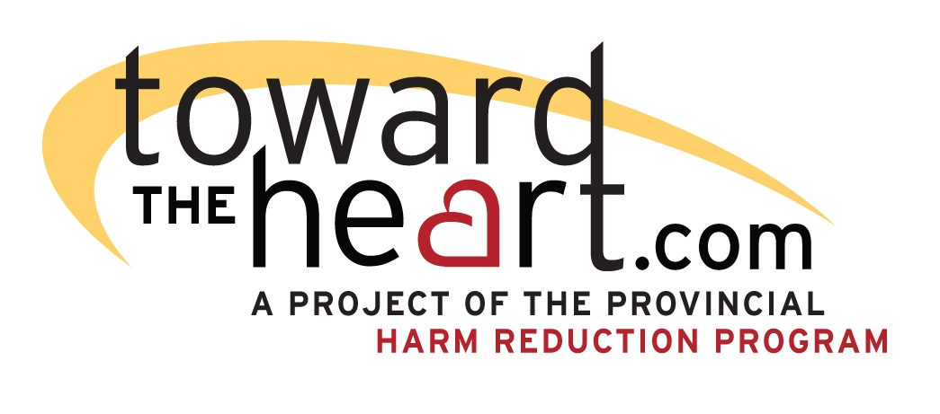
Note: This survey can be used to measure whether an individual possesses the competencies required for the Facility Overdose Response Box Program. You may need to modify the survey to reflect your site’s policies and procedures. It is recommended that an individual score at least 80% on this assessment. Any written evaluation should be accompanied by a practical evaluation of whether the individual knows how to put someone into the recovery position, perform rescue breathing, and prepare and administer an intramuscular injection of naloxone.
Organization
Employee Name
Date

Overdose (OD) Prevention

- Identify (CIRCLE) whether the following drugs are STIMULANTS, NON-OPIOID DEPRESSANTS (i.e. depressants that are not opioids) or OPIOIDS. (10 marks – 1 mark each)
- Heroin: | STIMULANT NON-OPIOID DEPRESSANT OPIOID
- Cocaine: | STIMULANT NON-OPIOID DEPRESSANT OPIOID
- Crack: | STIMULANT NON-OPIOID DEPRESSANT OPIOID
- Fentanyl: | STIMULANT NON-OPIOID DEPRESSANT OPIOID
- Crystal meth: | STIMULANT NON-OPIOID DEPRESSANT OPIOID
- Morphine: | STIMULANT NON-OPIOID DEPRESSANT OPIOID
- Benzos (e.g. Xanax, Valium, Ativan) | STIMULANT NON-OPIOID DEPRESSANT OPIOID
- GHB: | STIMULANT NON-OPIOID DEPRESSANT OPIOID
- Methadone | STIMULANT NON-OPIOID DEPRESSANT OPIOID
- Alcohol | STIMULANT NON-OPIOID DEPRESSANT OPIOID
- Identify (CIRCLE) whether the following factors would INCREASE (make more likely) or decrease (make less likely) the risk of an OD. (5 marks – 1 mark each)
- Deciding to snort instead of inject your fentanyl. | INCREASED RISK DECREASED RISK
- Using opioids with alcohol or sleeping pills. | INCREASED RISK DECREASED RISK
- Using an opioid after using cocaine. | INCREASED RISK DECREASED RISK
- Using your normal dose of heroin after being in the hospital for a few days. | INCREASED RISK DECREASED RISK
- Doing testers – taking a small amount of the drug first. | INCREASED RISK DECREASED RISK

OD Recognition

- Identify (CIRCLE) whether the following symptoms and signs are associated with a STIMULANT OVERDOSE, or an OPIOID OVERDOSE. (6 marks – 1 mark each)
- Loss of consciousness | STIMULANT OVERDOSE OPIOID OVERDOSE
- Rapid heartbeat | STIMULANT OVERDOSE OPIOID OVERDOSE
- Slow shallow breathing | STIMULANT OVERDOSE OPIOID OVERDOSE
- Lips and nails turning blue | STIMULANT OVERDOSE OPIOID OVERDOSE
- Agitation | STIMULANT OVERDOSE OPIOID OVERDOSE
- Unusual snoring or gurgling | STIMULANT OVERDOSE OPIOID OVERDOSE

OD Response

- Determine (CIRCLE) whether the following statements about naloxone are TRUE or FALSE: (6 marks – 1 mark each)
- It is only a temporary solution – it starts to wear off after 20 minutes. | TRUE FALSE
- It works for an OD that involves only Xanax, alcohol and cocaine. | TRUE FALSE
- If you think the person overdosed on fentanyl and the first dose hasn’t worked after 30 seconds, you should give another dose. | TRUE FALSE
- It will not be harmful if it turns out the person didn’t take any opioids. | TRUE FALSE
- It usually takes 3-5 minutes to work. | TRUE FALSE
- If someone experiences opioid withdrawal after being given naloxone, they could make it go away by taking more heroin. | TRUE FALSE

- Circle YES or NO to identify which of the following actions are part of responding to an opioid overdose (16 marks – 1 mark each)
Action | Part of the Proper Response to an Opioid Overdose?
Slap their face. | YES | NO
Let them sleep it off. | YES | NO
Tilt their head back. | YES | NO
Inject 1 dose of naloxone into their thigh every 30 seconds until they respond or help arrives. | YES | NO
Rub your knuckles on their sternum. | YES | NO
Check if they are breathing. | YES | NO
Inject the person with salt solution. | YES | NO
Pinch their nose and give 1 breath every 5 seconds. | YES | NO
Make sure nothing is in their mouth. | YES | NO
Shout their name. | YES | NO
Call 911. | YES | NO
Give them coffee or cocaine. | YES | NO
Put the person in a cold bath or put ice on them. | YES | NO
Inject 1 dose of naloxone into their thigh every 3-5 minutes until they respond or help arrives. | YES | NO
Tell emergency responders everything you know about the person and everything you have done for them. | YES | NO
Continue to give rescue breaths until the person is breathing on their own or help arrives. | YES | NO

- What is the best way for a layperson to administer naloxone? (choose the best answer; 1 mark)
- Put a tablet under the person’s tongue.
- Inject it straight into the person’s heart.
- Get the person to swallow a liquid.
- Inject it straight into the persons thigh.
- Inject it into a vein.

- Why do we put a person in the recovery position? (choose the best answer; 1 mark)
- It is comfortable.
- Prevent them from choking if they vomit.
- Prevent muscle cramping.
- To make the naloxone work faster.

- Would you give rescue breaths, chest compressions, or both, in the following scenarios (circle YES or NO) (8 marks):
- Clients observed their friend overdosing and come find you immediately. | RESCUE BREATHS | YES | NO
 | CHEST COMPRESSIONS | YES | NO
- You are doing a room check and come across a resident who is unconscious and not breathing. | RESCUE BREATHS | YES | NO
 | CHEST COMPRESSIONS | YES | NO
- You watch a client slump over and stop breathing. | RESCUE BREATHS | YES | NO
 | CHEST COMPRESSIONS | YES | NO
- On a scheduled bathroom check you find a client unconscious but gurgling and taking shallow breaths. | RESCUE BREATHS | YES | NO
 | CHEST COMPRESSIONS | YES | NO

- Are the following reasons you should stay and support an individual who has overdosed until emergency responders arrive TRUE or FALSE? (circle correct answer) (5 marks)
- Naloxone could wear off and the overdose could return. | TRUE | FALSE
- You may need to give an additional dose of naloxone. | TRUE | FALSE
- It is important to tell emergency responders about what actions you have taken. | TRUE | FALSE
- Discourage the person from immediately using again. | TRUE | FALSE
- Support the person through any withdrawal symptoms. | TRUE | FALSE

- What does SAVE ME stand for? Fill in the correct word(s) for each letter (6 marks)
S | Stimulate
A | Airway
V | Ventilate
E | Evaluate
M | Medication OR Muscular Injection (both/either is correct)
E | Evaluate

Facility Overdose Response Box Program

- Are the following statements about the Facility Overdose Response Box Program TRUE or FALSE? (circle the correct answer) (3 marks)

Naloxone will be automatically sent to the site every week. | TRUE | FALSE
It is mandatory to complete the Facility Overdose Response Box Naloxone Administration Form after responding to an overdose. | TRUE | FALSE
Anyone that works for a participating organization is allowed to administer naloxone. | TRUE | FALSE

-----The following questions will have to be customized for your site.-----

- A question to confirm whether staff know what debriefing are available to them.
- A question to confirm staff know what documentation requirements your organization has
- Questions about content of your organization’s policy and protocol including what to do if there are overdoses off-site and strategies your organization uses to monitor high risk areas
- Any additional questions that are relevant to your site and/or are related to the required competencies.

